How to: Configure Express to accept remote connections

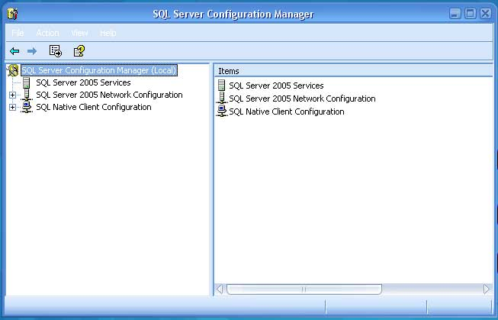

First, networking protocols are disabled by default in SQL Server Express.
Thus, if someone simply installs Express and chooses all the defaults, SQL
Server Express will only be able to have connections originating on the
local machine where SQL Server is installed.

To enable SQL Server Express to accept remote connections we need to perform
the following steps:

STEP 1: Enabling TCP/IP
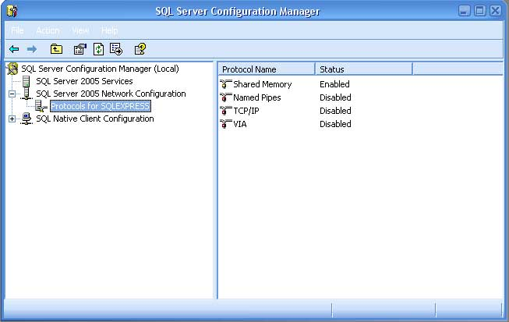

First we must tell SQL Server Express to listen on TCP/IP, to do this
perform the following steps:
- Launch the SQL Server Configuration Manager from the "Microsoft SQL
Server 2005 CTP" Program menu
- Click on the "Protocols for SQLEXPRESS" node,

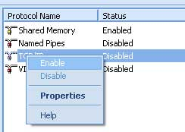
3. Right click on "TCP/IP" in the list of Protocols and choose, "Enable"

STEP 2: Configuring Properties
1. Launch the SQL Server Configuration Manager from the "Microsoft SQL
Server 2005 CTP" Program menu
2. Click on the "Protocols for SQLEXPRESS" node
3. Double click on the "TCP/IP" child node to open its properties

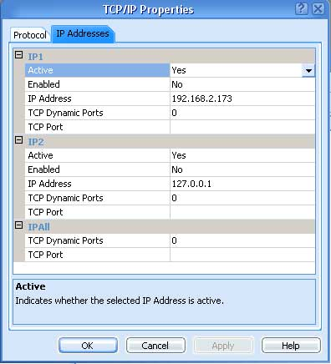

5. Clear out the value for "TCP Dynamic Ports"
6. Give a TcpPort number to use when making remote connections, for
purposes of this example lets choose, "2301"

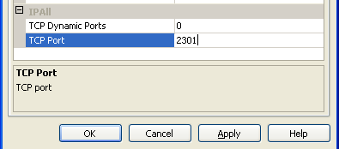

7. Right click the SQL Server Browser and select properties.
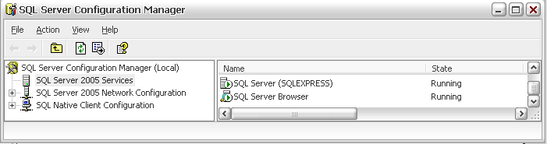
8. Change the Start Mode to Automatic.

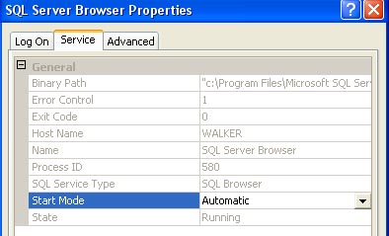

9. Right click the SQL Server Browser and choose start.
At this point you should restart the SQL Server Express service.

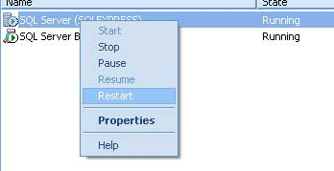

Windows XP Firewall

If you have installed SQLExpress on a Windows XP machine, you will have to add two executables to you Firewall exceptions list.

- Open control panel
In (Description view)
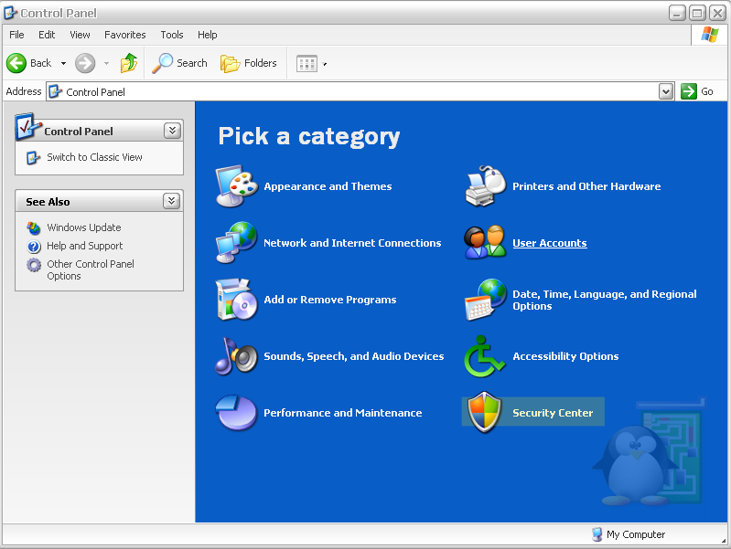

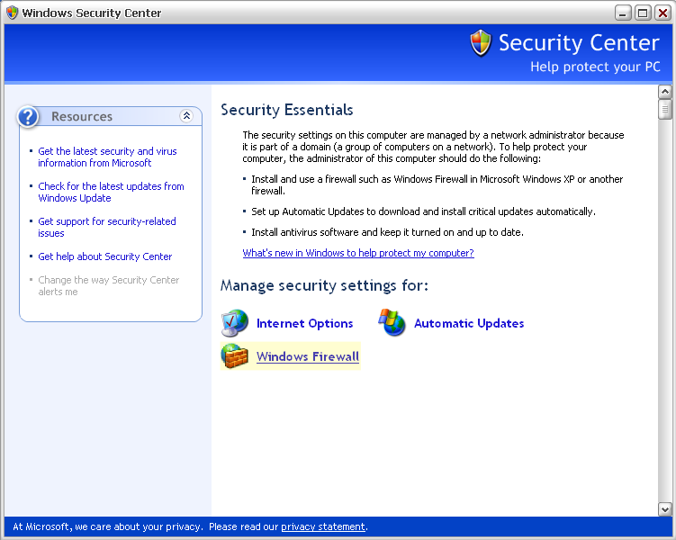
In (Classic view)
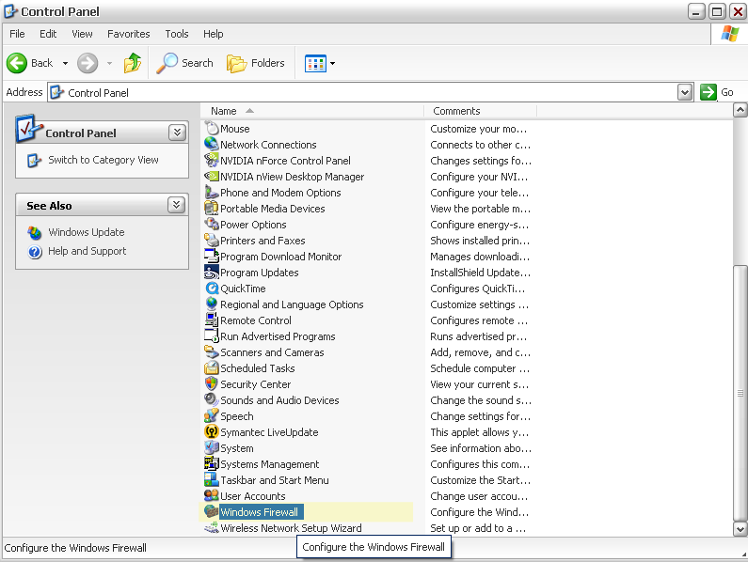

2. Exceptions
Once the firewall window is open, select the exceptions tab.
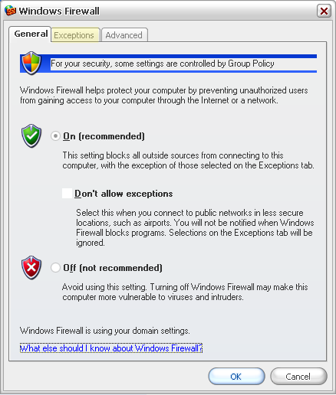

- Add program exceptions
We need to add to exceptions for the two major SQL components that MOG will be using. The first is the SQL Browser and the second is the SQL Server.
a. Press the “Add Program” button to add the first program.
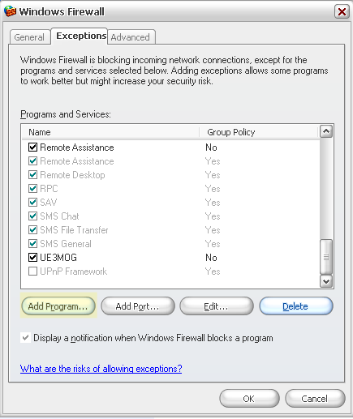

b. Browse to SQL Browser
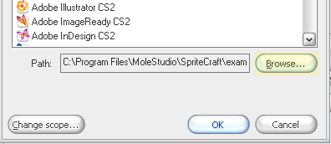

c. The SQL installation folder is usually located in the Program Files\Microsoft SQL Server folder. For the browser, enter the Program Files\Microsoft SQL Server\90\Shared folder.
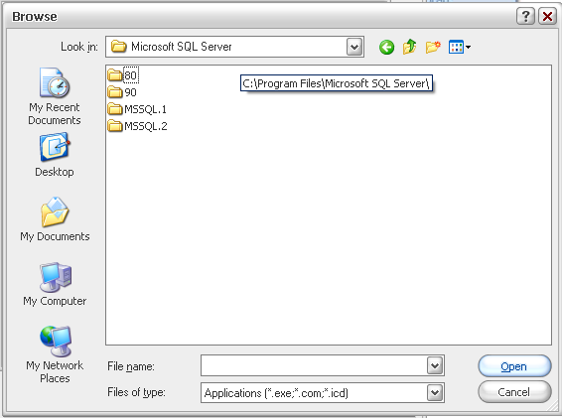

d. Select the sqlBrowser.exe and press “open”.
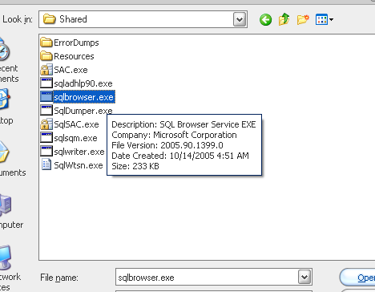

e. Now add another program exception for SQL Server by browsing to the Program Files\Microsoft SQL Server\MSSQL.2\MSSQL\Binn folder and select the sqlservr.exe and press “open”.
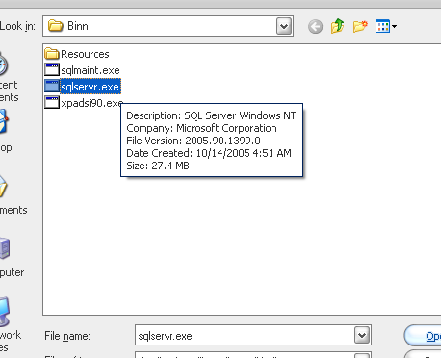

4. Once you have added the two programs to the firewall, your Exceptions list should look a little like this:
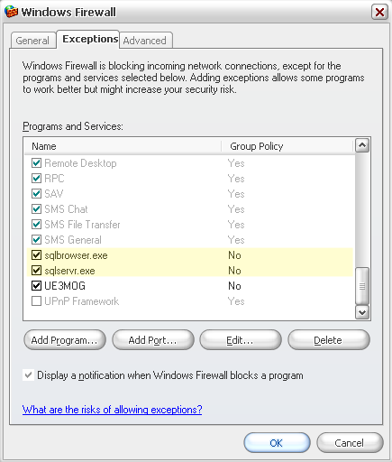

At this point you will be able to connect remotely to SQL Express.

